**Software engineering assignment**

**Esther Adebowale – 1903519**

**1A)**

<<Include>>

**1B)**

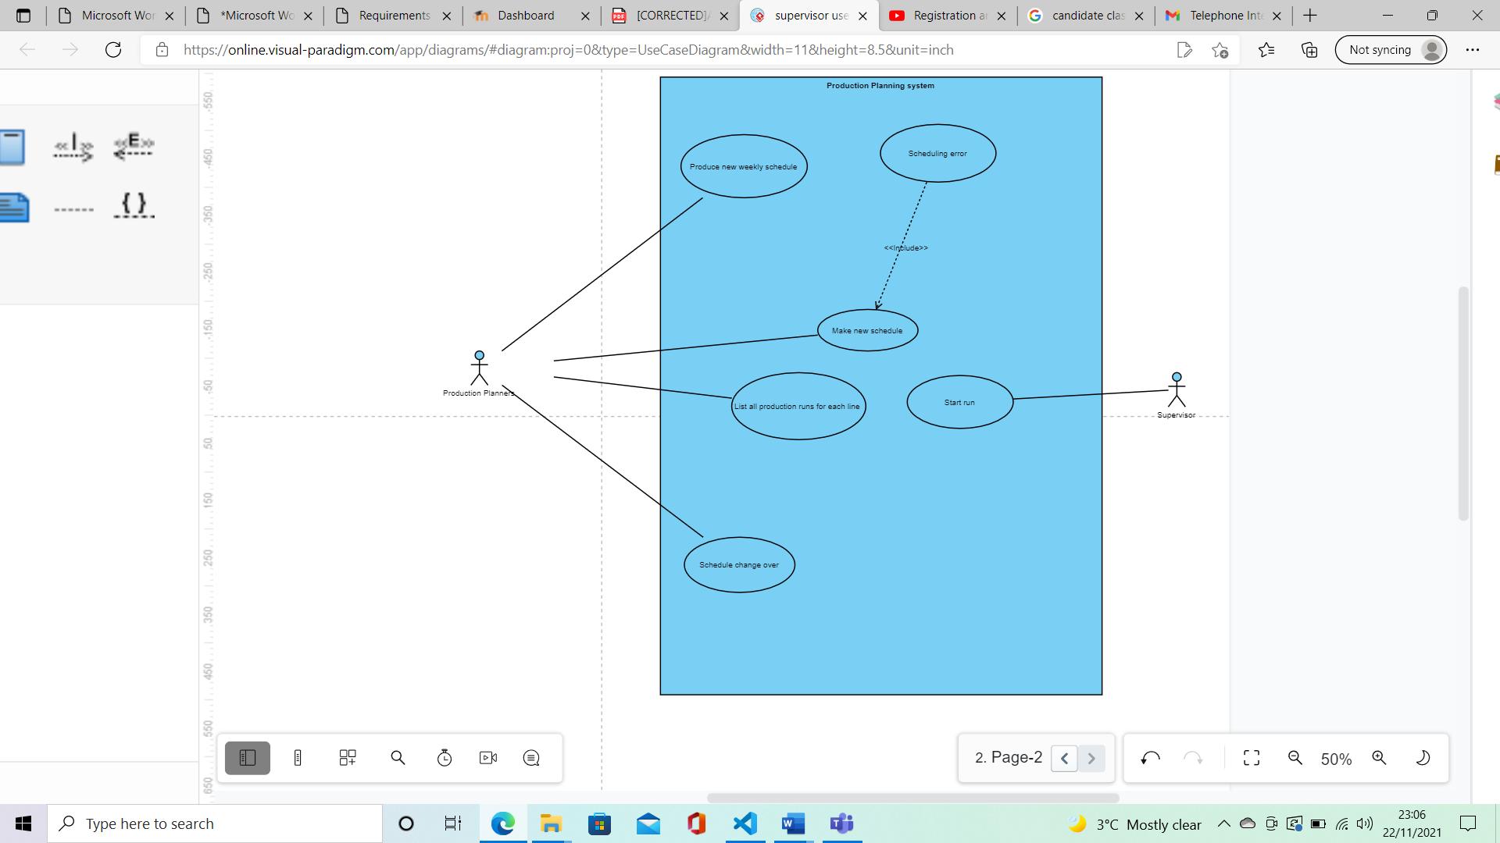

**1C)**

**START LINE RUN**

Name of use case:

Switch on line.

Pre-conditions:

The Supervisor must have been given the job card so they know what Ingredients are required. There needs to be enough ingredients to keep the line running until the next supply drop. The Supervisor checks if there are enough ingredients to start the line. The allocated staff must be present. The supervisor switches on the line

Post-conditions

The names and attendance of all the employees is taken by the supervisor. The production line is switch on by the supervisor successfully.

Actors involved:

Product line supervisor

Operative staff

Description

The supervisor checks the storage area to see if there are enough ingredients to start the line. Then checks the if the staff allocated to that production line are in attendance and notes their attendance. Once both conditions have been executed the supervisor switches on the line.

Alternative flow

There might not be enough ingredients at the start of a run. Staff might be missing, so the supervisor would have to find someone to replace them

Purpose:

Description of production line operation.

**RECORD EMPLOYEE JOINING THE LINE**

Name of use case:

Record time operative joined

Pre-conditions:

The employees allocated to the run have to show up to the line so they can be marked as present. The line supervisor switches on the line.

Post-conditions:

Once the supervisor successfully takes the employees name down, the employee can join the line

Actors involved:

Operative line staff

Production line supervisor

Purpose:

Description of supervisor noting down employee names

Description:

When the allocated staff present themselves at the beginning of the production line supervisor notes down their names and the time they joined. The supervisor notes down on the production n record sheet the job number from the job card.

Alternative courses:

If staff are missing, instead of noting down employees’ names and timing the line supervisor has to find other staff members to replace the absent ones.

**RECORD EMPLOYEE LEAVING THE LINE**

Name of use case:

Record employee leaving

Pre-conditions:

The line supervisor needs to start the line and the employee must be present in the first place. The supervisor must record the present employees

Post-conditions:

The employee’s absence is noted by the supervisor when they have left the line. The Supervisor looks for a replacement.

Actors involved:

Operatives

Production line supervisor

Purpose:

Description of how the supervisor will Record the name and time of employees when they leave the production line

Description:

When a member of staff, like an operative Leaves the production line the supervisor records the name of the name of the employee, the time they leave and for how long on the production record sheet and sometimes finds a replacement if someone is missing or sick.

Alternative courses:

**STOP LINE**

Name of use case:

End line

Pre-conditions:

The supervisor needs to start the line run. The staff allocated to that run need to be present in that run. The supervisor must end the line after a successful run.

Post-conditions:

The supervisor ends the line. The supervisor records the finish time of run, verifies the quantity produced with production control and works out the total hours for each operative.

Actors involved:

Supervisor

Purpose:

Description of production line being ended by supervisor

Description:

The supervisor ends the production line and the end of the run. They record the end time of the line and verify the quantity produced that run with production control. They work out the total hours worked by each operative and absences.

Alternative courses:

The line may stop because of other reason to do with line breakdown. Production control may have to intervene. The supervisor must record the downtime and find something productive for employees to do during.

**RECORD LINE PROBLEM**

Name of use case:

Note down line problem

Pre-conditions:

The supervisor must have all the information to do with the line breaking down in order make note of it. The supervisor must have access to the production record sheet. The line must be stopped by the supervisor and maintenance must be brought in (present).

Post-conditions:

A note detailing the breakdown is made by the supervisor on the production record sheet. The line has been successfully fixed most likely by maintenance and has started up again.

Actors involved:

Supervisor

Maintenance

Purpose:

Description of a production line breakdown being noted by the supervisor

Description:

The supervisor gets all the information about the line break down. They note down on the production record sheet the details of the breakdown. They may call for maintenance depending on the specific issue. If ingredients have run out the supervisor will call the farm supplier or warehouse. If operative have gone missing or are sick the supervisor finds a replacement for them. They record downtime on the production control sheet and look for something productive for employees to do in the meantime. When the issue is fixed, they re-start the line and record the start time.

Alternative courses:

The supervisor might not know the reason for the line breakdown.

**END LINE RUN**

Name of use case:

End line

Pre-conditions:

The supervisor switches on the line and the staff allocated to that line are present. The staff and supervisor has finished their run. Production control is present.

Post-conditions:

The supervisor ends the line and makes note of the end time on the production sheet.

Actors involved:

The supervisor

Production control

Purpose:

Description of the process of the end line operation

Description:

The supervisor ends the production line run when the staff and employees have finished. The supervisor. The supervisor verifies the quantity by calling someone from production control to verify the quantity. They record the end time of the run, absences and work out the hours worked by operatives. Anew timesheet is added by the supervisor for the people that joined the production line in the middle of the run. The unused ingredients are returned to the warehouse. The line is tidied up and made ready for the next run.

Alternative courses:

Sometimes the line may end by itself due to a lime breakdown.

**1D)**

**Candidate classes:**

Production line

Production record sheet

Time sheet

Supervisor

Storage area

Ingredients

Production planner

Raw materials

Maintenance

Supplier

Paperwork

Troubleshooting

Employee absence

Changeovers

Warehouse

Production control

Job number

Operative

Production Schedule

Job Card

Production card

Piecework Rate

Replacement employee

|  |  |  |
| --- | --- | --- |
| Boundary | Entity | Control |
| * Piecework rate * Changeovers * Employee absence * Paperwork * Production record sheet * Production line * paperwork | * Supervisor * Operative * Raw materials * Timesheet * Job card   Replacement employee   * Maintenance | * Production Schedule * Production control * Warehouse * Ingredients * Employee absences * Job number * supplier |

**2)**

**START LINE RUN communication diagrams**

**RECORD EMPLOYEE JOINING THE LINE**

**RECORD EMPLOYEE LEAVING THE LINE**

**STOP LINE**

**RECORD LINE PROBLEM**

**3)**

**

c.

I do believe my diagram are consistent with one another in terms of the entities and classes that have been defined.